MINISTRY

# OF

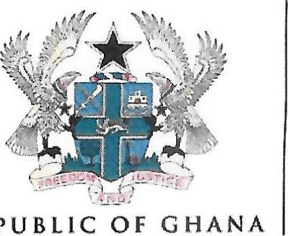REPUBLIC OF GHANA INFORMATION

P. O. Box M41, Accra - North

Digital Address : GA-076-8230

Kindly quote this number and date on all correspondence My Ref. No.PG12G / j / 02



Your Ref. No.

|  |  |
| --- | --- |
| 13 | C) 1  0  — |

Dale.

ADHOC MINISTERIAL COMMITTEE TO ENGAGE

STAKEHOLDERS ON ILLEGAL MINING

On the instruction of the President of the Republic, Nana Addo Dankwa Akufo-Addo, an adhoc Ministerial committee has been set up to engage all stakeholders to assess government's efforts in dealing with illegal mining in Ghana.

The five-member committee is led by the

1. National Security Minister, Hon. Albert Kan-Dapaah

Other members of the committee are:

1. Minister for Lands and Natural Resources, Hon. Samuel A. Jinapor
2. Minister for Defense, Hon. Dominic Nitiwul
3. Minister for Employment, Labour Relations and Pensions, Hon. Ignatius Baffour Awuah
4. Minister for information, Fatimatu Abubakar

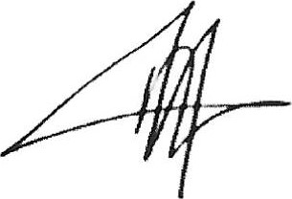

FATIMATU ABUBAKAR

MINISTER

Tel: +233 (0) 302 909 609 Email : info@moi.gov.gh Website : www.mol.gov.gh